Name **Nuzhat Qureshi**

Roll No BIT-24S-029

Github link <https://github.com/NuzhatQureshi90/Pythons-lab-manual-IT-A-/upload/main>

**LAB MANUAL 04**

**TASK 1:**

Q.1. Basic Task: Write a program that checks if a given number is positive, negative, or zero.

Program:

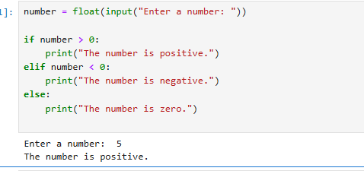

**TASK 2:**

Q.1. Intermediate Task: Write a program that takes user input and determines whether it's a even or odd.

Program:

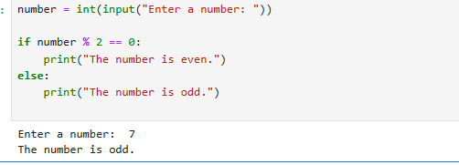

**TASK 3:**

Advanced Task: Create a program that asks user to print:

"Excellent" if marks are above 80

"Good" if marks are between 60 and 80

"Needs Improvement" if marks are below 60

Program:

